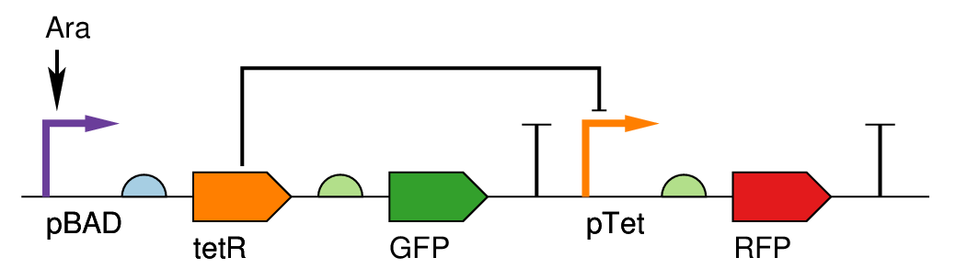**BBa_K783067**

This device is specified to act as a logical inverter as a function of [L-arabinose]. GFP expression should increase as L-arabinose concentration increases and RFP expression should decrease. Characterization finds behavior consistent with specification.

I13453 B0032 C0040 B0034 E0040 B0015 R0040 B0034 E1010 B0015

Author(s): Evan Appleton, Monique Freitas, Sonya Iverson Contact: eapple@bu.edu

Data Collection: Evan Appleton, Monique Freitas Related Parts: BBa_I13453, BBa_C0040, BBa_R0040

Affiliation: Boston University (Densmore Lab) Date: 9/20/2012

Additional Comments: SI built device, EA and MF characterized device.

Chassis: E. coli Strain: Bioline™ α-Gold

PRE-INDUCTION GROWTH CONDITIONS INDUCTION GROWTH CONDITIONS

Media Type: Luria Broth (LB) Media Type: Luria Broth

Vessel: 5 mL tubes Vessel: 500 μL tubes

Volume: 2 mL Volume: 200 μL

Incubation: 37°C, 300 rpm Incubation: 37°C, 300 rpm

Time (min): 420 Time (min): 870

MEASUREMENTS TECHNOLOGIES:

(1) Flow Cytometer (2) Restriction Mapping

Data Type: Single-cell fluorescence Data Type: Gel electrophoresis (DNA size bands)

Location: Boston University Center for Advanced Biotech Location: Boston University Center for Advanced Biotech

Machine Name: SORP 4B-2YG-1BV, ACDU (FACSAriaII) Machine Name: (N/A)

Data Format: FCS 3.0 data files Data Format: Gel pictures

Additional Info: Lasers:(Filters) 445nm, 40mW:(515/20nm); Additional Info: 1% TAE gel; Sybr dye used for staining

488nm, 50mW: (488/10, 515/20, 545/35, 610/20,

710/50nm); 561nm, 40mW:(610/20, 660/20nm);

Device Name: BBa_K783067 Assembly: BioBricks™

Device Type: Inverter Protocol: BU BioBricks assembly protocol

Description: pBad-pTet inverter Scars: Yes; 6bp scars between each part

Components: BBa_13453-BBa_B0032-BBa_C0040-BBa_B0034- Insertion: Plasmid

BBa_E0040-BBa_B0015-BBa_R0040-BBa_B0034- Vector: pSB1A3

BBa_E1010-BBa_B0015

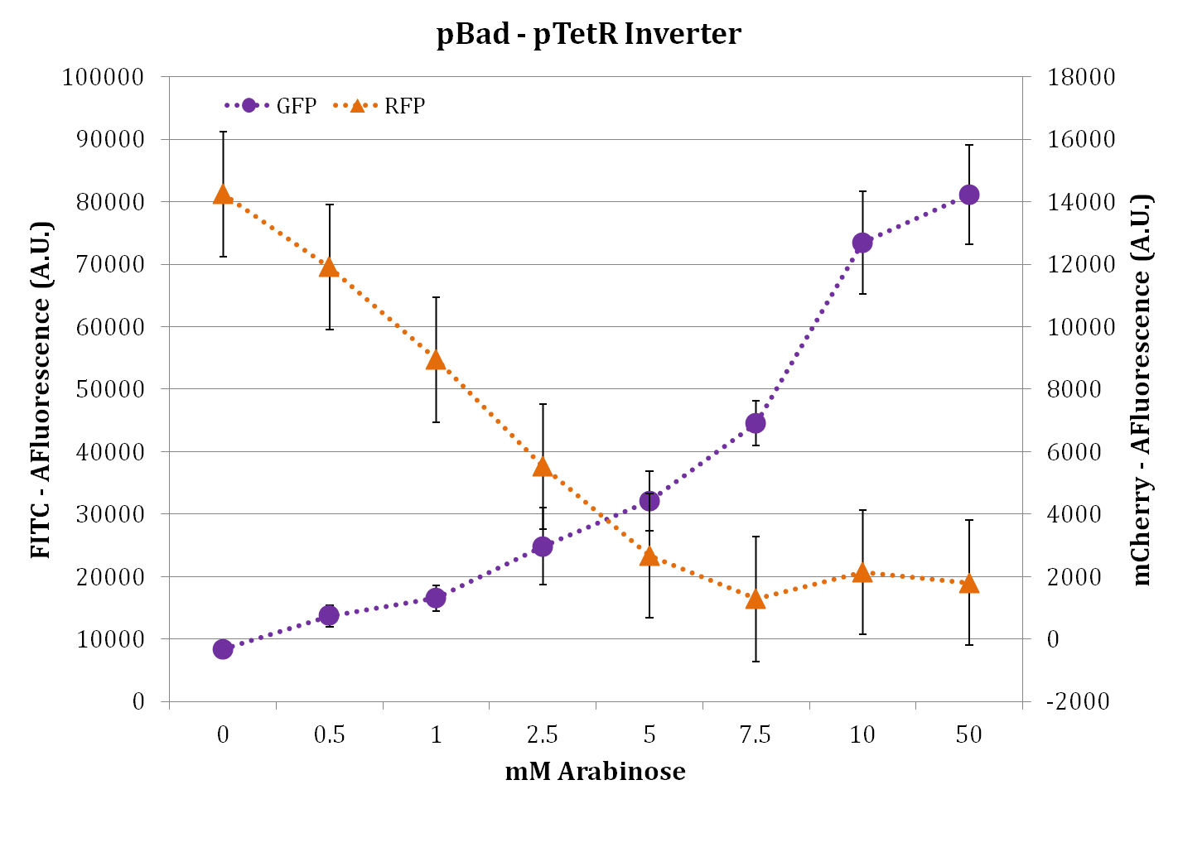 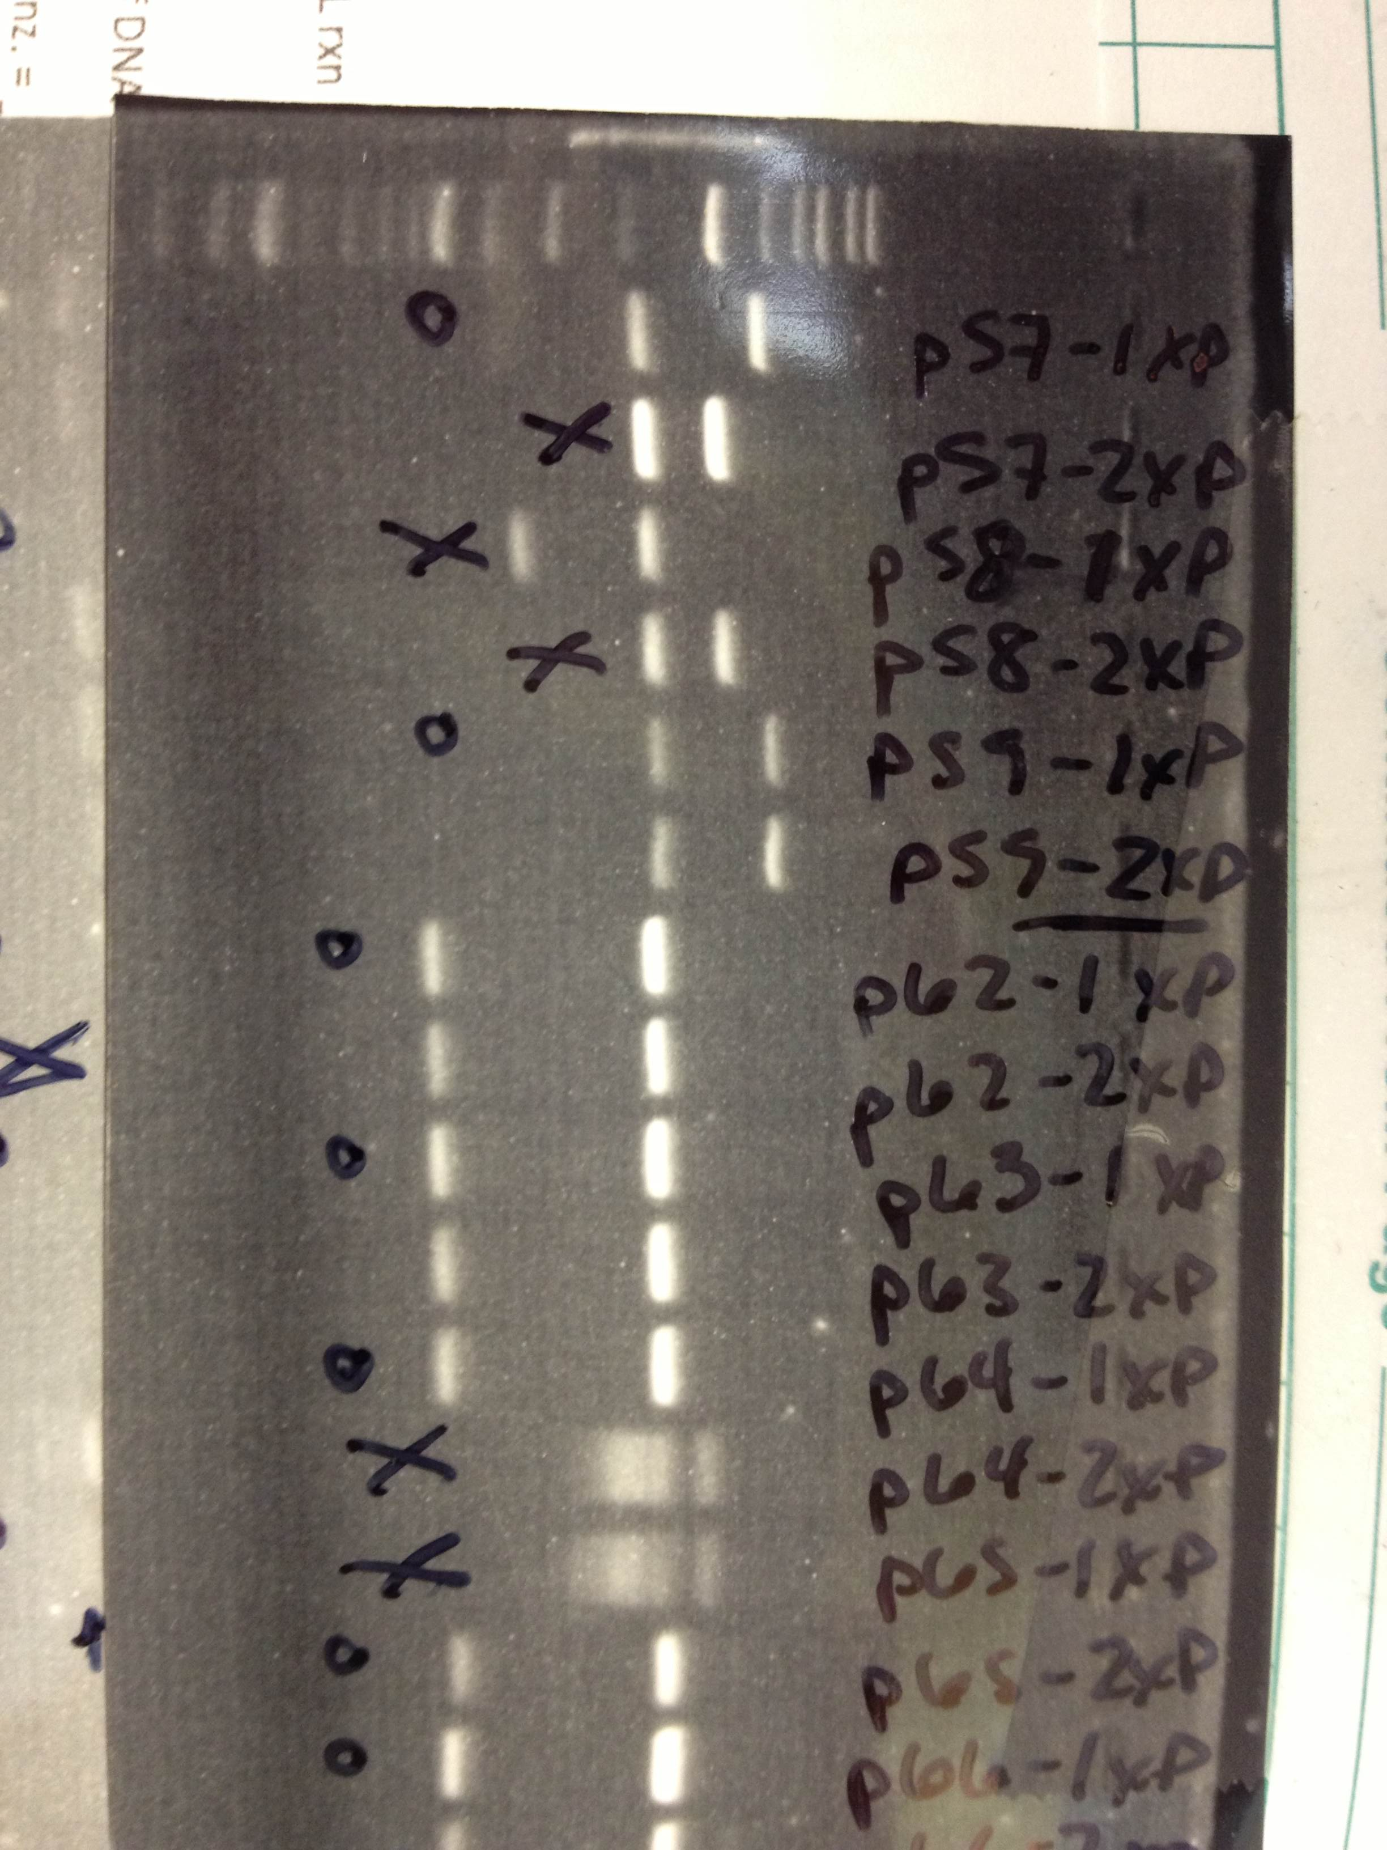

FIGURE 2: Restriction mapping for BBa_K783067 (seen here as pSI59-1) has the correct part length according the marker, indicating the proper construction of the device.

FIGURE 1: Flow cytometry measurements at variable L-arabinose concentrations. Three device clones were tested to obtain error bars. GFP fluorescence measured on 488nm laser, 515/20nm filter. RFP fluorescence measured on 561nm laser, 610/20nm filter.